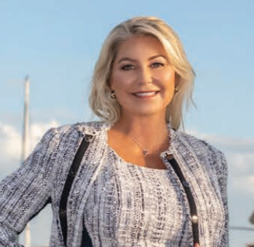
Alyssa has a deep background in financial services exceeding twenty years working with high-net-worth families and business owners worldwide and supervising advisors and staff involving over $15 billion in client assets.

Having spent 17 years at Smith Barney turned Morgan Stanley at wire house firms in both production and management, Alyssa maintains her registrations with NAMCOA®, (Naples Asset Management Co, LLC®) and maintains the AIF® (Accredited Investment Fiduciary®) and PPC® (Pension Plan Consultant) designations.

After undergoing unexpected double bypass open heart surgery, Alyssa transitioned into her role with Phillips Cohen & Associates, a global firm with over 25 years in compassionate care and probate resolution services. She brings her experience and expertise in working with estate planning professionals and families in the creation of compassionate care resources that provide life planning, executor, and beneficiary support.

Alyssa is a year-round Sarasota Florida resident and active in several organizations. She is a past national and local board member of the US Committee for United Nations Women Foundation, National Heart Association Circle of Red supporting member, CANTER, a thoroughbred rescue association, and a speaker at the US Government Wi$eUp program strengthening financial literacy fostering tomorrow's leaders.

